What Is a Determiner?
An important role in English grammar is played by determiners – words or phrases that precede ( come before) a noun or noun phrase . They are required to express its reference in the context / to give more information about the noun. It can be said that Determiners are used with nouns to clarify the noun.
The type of determiner used depends on the type of noun.
- Singular Nouns (except proper noun)- always needs a determiner
- Plural Nouns - the determiner is optional
- Uncountable Nouns - the determiner is also optional
There are about 50 different determiners in the English language they include:
- Articles - a, an, the
- Demonstratives - this, that, these, those, which etc.
- Possessive Determiners - my, your, our, their, his, hers, whose, my friend's, our friends', etc.
- Quantifiers - few, a few, many, much, each, every, some, any etc.
- Numbers - one, two, three, twenty, forty
- Ordinals- first, second, third etc

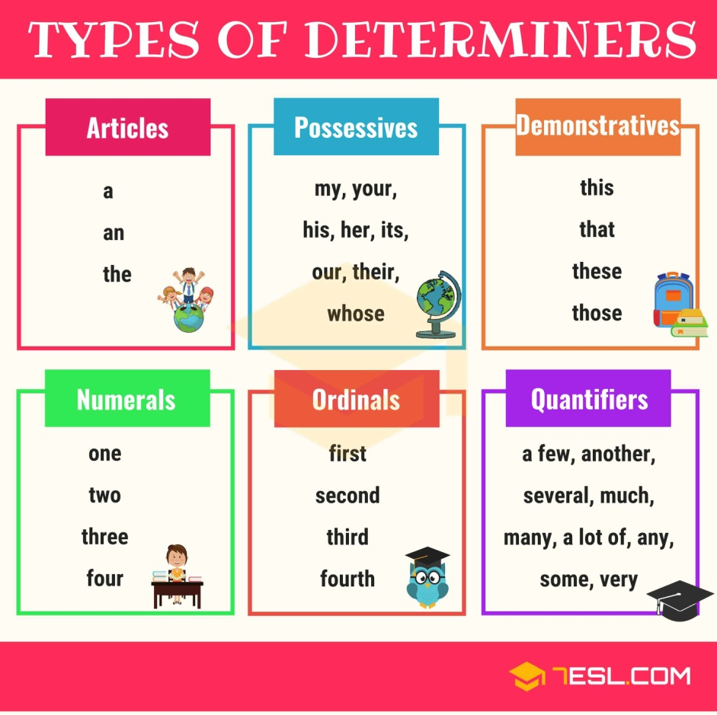.
As we have already covered ‘Articles in the previous chapter, let us begin with demonstratives -
There are 4 demonstratives - That - This - These - Those Demonstratives are used to state the distance from the speaker. The distance can be either psychological or physical.
They are sometimes referred to as demonstrative adjectives or demonstrative pronouns as they can be used as pronouns or adjectives . When they are used as adjectives they modify the noun.
This – is used with singular nouns, when referring to an object that is close to the speaker
- This book is interesting.
- Is this your bag?
That – is used with singular nouns, when referring to an object or person that is far to the speaker
- That is your bag.
- Is that your bag?
- That is not my bag.
These - is used with plural nouns, when referring to an object that is close to the speaker
- These clothes need to be put in the drawer.
- Are these clothes for me?
- These plants look very nice.
Those - is used with plural nouns, when referring to an object or person that is far to the speaker
- I really like those cars.
- Are those your friends?

Possessives

Possessives are forms that we use to talk about possessions and relationships between things and people. They take different forms depending on how they are used.
Possessive determiners indicate possession or ownership of someone, something, or some place, a part of a thing or body, a feeling or thought, an event etc. They use words such as my, your, his, her, its, our, and their and are used before a noun.
- This is my book.
- Is she your sister ?
- He put his hand on my shoulder.
- It was difficult to hide my excitement.
- When is her wedding?
But remember , the other set of possessives ( mine, yours, ours, theirs ,hers) are not determiners. They are possessive pronouns. . The basic difference, they say, "is that pronouns replace full noun phrases. Possessive determiners, on the other hand, have to occur with a noun"

The definite determiner the may be used instead of a possessive determiner. However, when referring to someone in the family or a relative, the may not be used.

Examples:
- She punched him on his nose.
- She punched him on the nose.
- We walked back to our house when it started to rain.
- We walked back to the house when it started to rain.

The definite determiner the may not be used.
- No: The wife is watching me cook.-X
- Yes: My wife is watching me cook.
- No: I called the uncle to hurry up. -X
- Yes: I called my uncle to hurry up.

Quantifiers
What are quantifiers?
Quantifiers are used to state quantity or amount of something without stating the actually number. They answer the questions "How many?" and "How much?" Some examples are-
1. Words indicating a large or small quantity and their comparative and superlative forms
Examples: much/many, little/few, more, most, less/fewer, least/fewest.
Examples: a lot of, lots of, plenty of, a great deal of, tons of, etc.

2. Words and phrases expressing some unspecified or probably quite small amount
Examples: a few/a little, several, a couple of, a bit of, a number of, etc.

3) Phrases expressing precise quantity
Examples: a pair of, five liters of, etc.
4. Words and phrases expressing multiples or fractions
Examples: half, half of, double, twice, three times, twice as much, etc.
5. Words expressing maximum, sufficient or zero quantity
Examples: all, both, enough, sufficient, no.
Note that many of these quantifiers can be modified by adverbs and adverbial phrases such as almost, over, more than, less than, when the meaning is appropriate.
Quantifiers can be used with plural countable nouns and uncountable nouns.
There are 3 main types of quantifiers-
Quantifiers that are used with countable nouns,
quantifiers that are used with uncountable nouns.
quantifiers that are used with either countable nouns or uncountable nouns.
Quantifiers With Countable Nouns
- A Few - I have a few books.
- Many - I have many friends.
- Several - My father has several workers.
Quantifiers With Uncountable Nouns
- Few - We have few friends.
- Much - How much work is there?
- Little - I have a little money.
Quantifiers With Countable Nouns & Uncountable Nouns
• No - We have no car. - Countable Noun
• No - We have no time. - Uncountable Noun
• All - I have all the books. - Countable Noun
• All - I have all the money. - Uncountable Noun
• Plenty - There is plenty of water. - Countable Noun
• Plenty - There is plenty of food. - Uncountable Noun
- Enough - We have enough boxes.- Countable Noun
- Enough- I have enough money - Uncountable Noun

Some and any can be used when:
The exact number is not known or the exact number is not important or relevant.
Some and any are used with countable nouns and uncountable nouns.
Some - is used in positive sentences, offering & requests
- I am going to buy some cake for tonight.
- We have to make some phone calls.
- They have to bring some money, so they can pay me.
- Can I have some more tea, please?
- Can you do some work for me on Tuesday?
Any - used in negative sentences, to state something does not matter
- I am not going to buy any cake for tonight.
- We do not have to make any phone calls.
- They do not have to bring any money.
- We like any kind of bread.
- I am happy to go any place.
Someone - is used with positive statements & with questions but only when you think or know the answer will be positive
- I want someone to come with me to the store.
- The dogs want someone to feed them.
- Does someone want to go out for dinner tonight?
- Does someone want cake?
Anyone - is used with negative statements & questions
- I don't want anyone to call me today.
- We don't know anyone who smokes cigarettes.
- Does anyone want to go to the store with me?
- Does that book belong to anyone?

Much & many are words that are very similar. There is only one difference:
Many - is used with countable nouns (something we can count)
- I don't have many apples.
- Do we have many people coming to visit tomorrow?
- I have many books.
Much - is used with uncountable nouns (something we can't count)
- I don't have much time today.
- The dogs at the dog shelter have so much love to give to someone. I hope all the dogs get a home.
- We have to much laundry too do today.
No - no + noun; a noun is needed after "no"
- I have no money.
- We have no place to live.
- My sister has no idea about computers.
- I have no brothers. I have only two sisters.
- We have no time to help you.
None - is used without a noun
- How many books do you have? None.
- None of my friends came to visit me in the hospital.
- I knew none of the answers.
- This is none of your business.
- None of the book are ours.
Attempt the exercises in chapter 7 – Determiners and Quantifiers. If there is any doubt, send a message on whatsapp.

